Name Mustafa
Sp23-bse-67
COMMUNICATION DIAGRAM FOR
STUDENT FEEDBACK SYSTEM
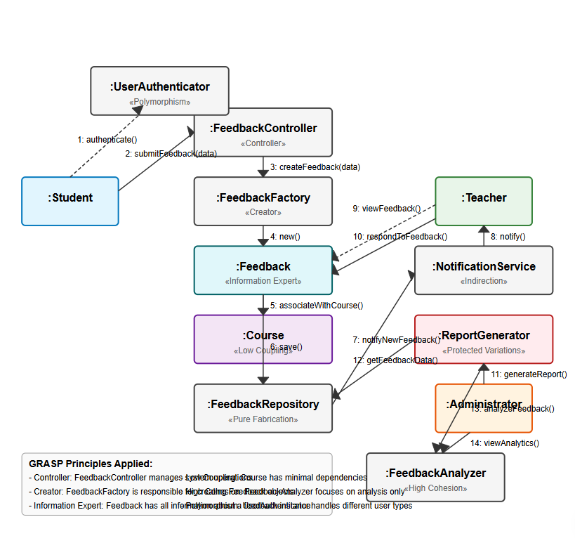

This communication diagram illustrates how objects in the student feedback system interact with each other, following GRASP (General Responsibility Assignment Software Patterns) principles. Each class has been assigned specific responsibilities based on these principles:

Key GRASP Principles Applied:
- Controller: FeedbackController manages system operations and coordinates the feedback submission workflow
- Creator: FeedbackFactory is responsible for creating Feedback objects
- Information Expert: Feedback class contains all information about a feedback instance
- Low Coupling: Course class has minimal dependencies on other classes
- High Cohesion: FeedbackAnalyzer focuses exclusively on analyzing feedback data
- Pure Fabrication: FeedbackRepository provides a storage abstraction layer
- Indirection: NotificationService mediates between Feedback and Teacher
- Protected Variations: ReportGenerator encapsulates reporting logic to protect against changes
- Polymorphism: UserAuthenticator handles different user types uniformly

Communication Flow:
- Student authenticates via UserAuthenticator
- Student submits feedback data to FeedbackController
- FeedbackController delegates to FeedbackFactory to create feedback
- FeedbackFactory instantiates a new Feedback object
- Feedback associates itself with the relevant Course
- Feedback is saved to the FeedbackRepository
- FeedbackRepository triggers the NotificationService
- NotificationService notifies the Teacher of new feedback
- Teacher views feedback details
- Teacher responds to feedback
- Administrator requests reports through ReportGenerator
- ReportGenerator retrieves data from FeedbackRepository
- ReportGenerator uses FeedbackAnalyzer for in-depth analysis
- Administrator views analytics through FeedbackAnalyzer
This diagram demonstrates how responsibilities are distributed according to GRASP principles, promoting a modular, maintainable architecture with clear separation of concerns. Each component has a specific responsibility, and the communication between them follows logical sequences based on their relationships.

